|  |
| --- |
| **JDN Standards – Deployment fat clients** |

Introduction 1

Guidelines 1

Software installed on fat clients on board 1

# Introduction

This document provides guide lines for deployment of fat clients within the JDN Standards for Vessels as defined in 2015. Core software will only be installed on virtual machines hosted by the server infrastructure of the vessel and never on the fat clients provided by IT.

# Guidelines

## Software installed on fat clients on board

* JDN Quick support (Teamviewer version)
* ESET antivirus
* IT Helper (custom config is in test until packet is ready)

## User rights

Create a local user with username pointing to the location the pc will be used (ecr, office, captain, chief,...) using the run command ‘netplwiz’. The password of this account should be the same as the username.

E.g.

**Username**: office

**Password**: office

Add this user to the local administrators group.

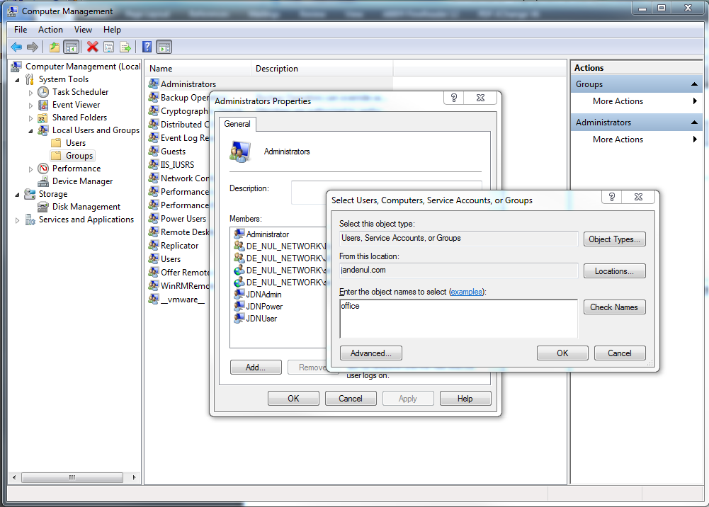

## Remote desktop shortcut

Reboot, login using the newly created credentials.

Create a RDM shortcut on the desktop of the user:

Set FQDN of the virtual machine and the username (include domain)

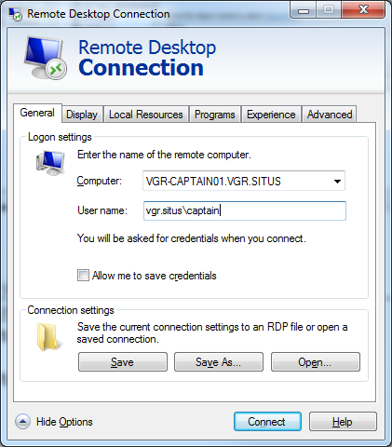

Display settings:

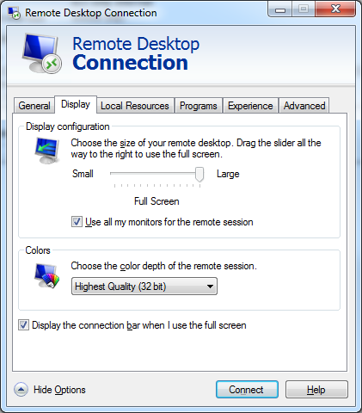

Local Resources:

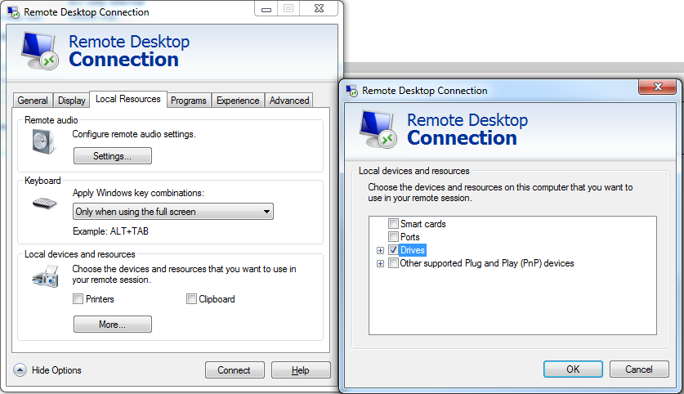

Save as name of the virtual machine on the desktop.